The story so far ...

Max is the hero of this game. He's a teenager who has adopted a talking cat ... Yes, you've read well, a talking cat, who only want to eat fresh fish !

So, our hero decided to go fishing to feed his strange cat.

Max, the hero AKA you ! :

Your cat :

And some food :


Getting ready to play :

Here is the main menu of this game :

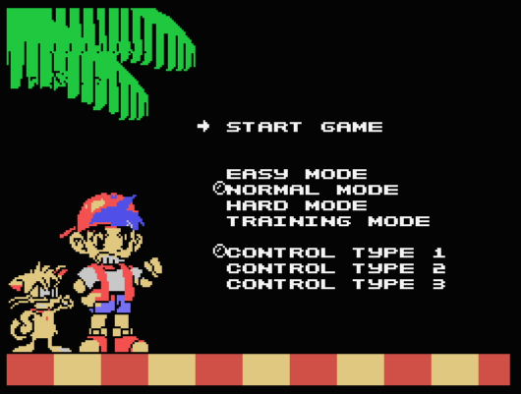

You move in this menu with the joypad and select an entry with button 1.

START GAME : Start fishing !!

EASY MODE : Choose to play the game in easy mode (38 Levels)
NORMAL MODE : Choose to play the game in normal mode (38 Levels)
HARD MODE : Choose to play the game in hard mode (38 Levels)

TRAINING MODE : Choose to play the training game (18 Levels).

CONFIG TYPE 1 : Choose control mode 1
CONFIG TYPE 2 : Choose control mode 2
CONFIG TYPE 3 : Choose control mode 3

Using your controller.

The control change with your "CONFIG TYPE" choice in the menu.

CONFIG TYPE 1 :
BUTTON1 : Drop the fish
BUTTON2 : Switch the fish

CONFIG TYPE 2 :
BUTTON1 : Switch the fish
BUTTON2 : Drop the fish

CONFIG TYPE 3 :
BUTTON1 : Switch the fish
DOWN : Drop the fish

Getting started.

Choose the difficulty level, and the config type in the menu, then choose Start Game. That's so easy !!

The Game Zone :

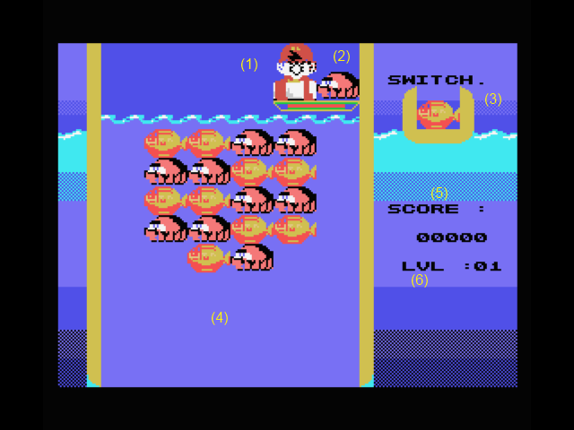
- This is Max, on his marvelous boat !
- This is a fish ... This one will be drop in the water to catch other fish
- This is a fish too ... It is in your basket. You can switch this fish with the one in your boat.
- This is the sea. If the fishes go down, you loose !!
- This is your score
- And the number of the current level.

Game system :

To feed your cat, you must group at least 3 fishes, and one of them must be at the top of the sea. Examples :

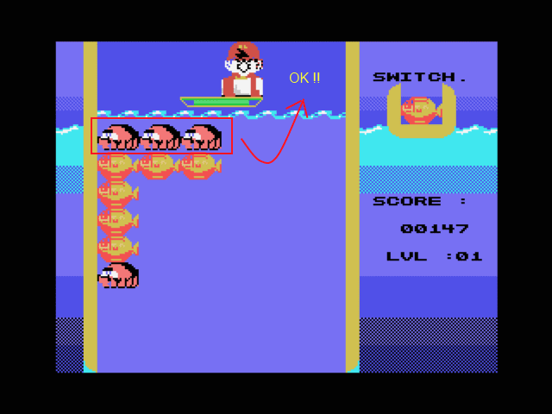
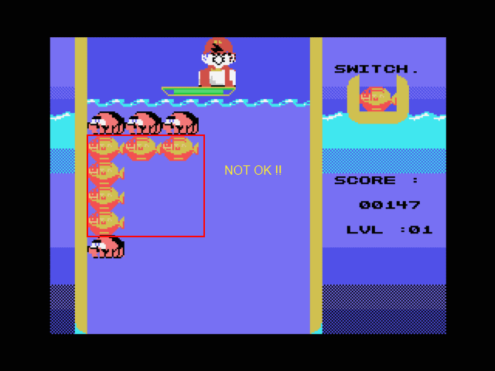

Every 7 fish drop, the sea level go down. If you are too long to drop the fish, it drop by itself. (Yes a fish is slippy !!).

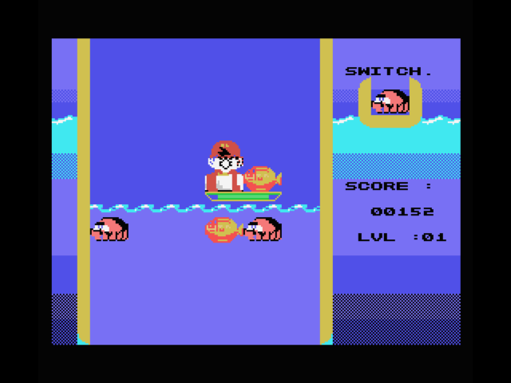
If a fish is at the bottom of the sea and the water level go down ... You loose !

Scoring and combo :

Each fish count for 1 point. Catching many type of fish with only one is called a Combo, and multiply your points.

Example :

Max drop a fish, and catch 3 other fish : 3 * 1 point = 3 points
The others fish go up, and align themselves, you catch another 3 fishes : 3 * 1 point * 2 (Combo) : 6 points
Another 4 fishes align : 4 * 1 points * 3 (Combo) = 12 points
Total : 21 points

What the level of difficulty change :

The difficulty level change what is the next fish you'll get.

Easy level : The next fish will be one of the fish in the 2 first line of the sea.

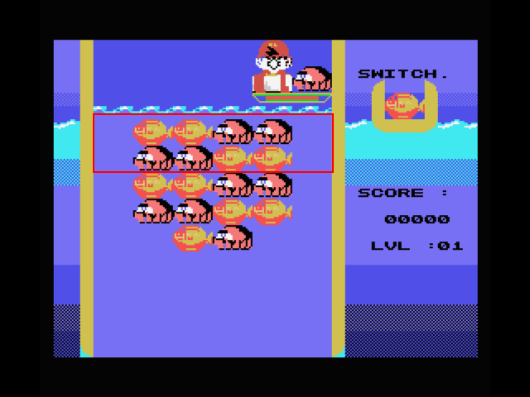
Normal Level : The next fish will be one of the fish in the 3 first line of the sea.

Hard Level : The next fish will be one of the fish in all the sea !!!! (Yes, that's why it's called hard level !).

Conclusion :

Now, you know what to do to feed this strange cat. No, don't by food at the supermarket, PLAY THIS GAME !!

